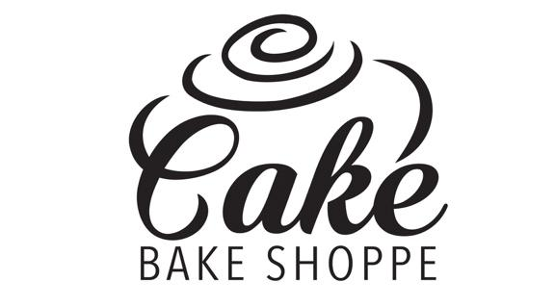
LIST OF INGREDIENTS

CAKE/CUPCAKES

Chocolate Cake: flour, sugar, canola oil, vinegar, baking soda, salt, cocoa powder

Gluten Wise Chocolate Cake: sugar, canola oil, vinegar, baking soda, salt, cocoa powder, rice flour, potato starch, pea hull fibre, tapioca starch, xanthan gum.

Vanilla Cake: milk, canola oil, vinegar, vanilla, sugar, flour, baking soda, salt, eggs

Gluten Wise Vanilla Cake: milk, canola oil, vinegar, vanilla, sugar, baking soda, salt, eggs, rice flour, tapioca starch, potato starch, pea hull fibre, tapioca starch, xanthan gum.

Red Velvet Cake: flour, sugar, baking soda, salt, cocoa powder, canola oil, buttermilk, eggs, red food colour, vinegar, vanilla

Gluten Wise Red Velvet Cake: sugar, baking soda, salt, cocoa powder, canola oil, buttermilk, eggs, red food colour, vinegar, vanilla, rice flour, potato starch, pea hull fibre, tapioca starch, xanthan gum.

Carrot Cake: carrots, eggs, buttermilk, canola oil, sugar, flour, salt, cinnamon, baking powder, baking soda, ginger, clove

Cookies & Cream Cake: milk, canola oil, vinegar, vanilla, sugar, flour, baking soda, salt, eggs, Oreo cookies

Gingerbread Cake: flour, sugar, canola oil, eggs, milk, vanilla, vinegar, baking soda, salt, cinnamon, nutmeg, all spice, ginger, molasses

Eggnog Cake: flour, sugar, canola oil, eggs, eggnog, vanilla, vinegar, baking soda, salt, cinnamon, nutmeg

ICING

Cream Cheese Frosting: cream cheese, butter, icing sugar

Buttercream (with flavour variations): butter, icing sugar

Vegan Buttercream: plant based butter alternative, vegetable shortening, icing sugar, vanilla bean paste

Royal Icing: icing sugar, meringue powder, water

COOKIES

Chocolate Chip Cookies: butter, brown sugar, eggs, flour, baking powder, baking soda, salt, cornstarch, chocolate chips

Smartie Cookies: butter, brown sugar, eggs, flour, baking powder, baking soda, salt, cornstarch, Smarties

Double Chocolate Chip Cookies: butter, brown sugar, eggs, flour, baking powder, baking soda, salt, cornstarch, chocolate chips, cocoa powder

Snickerdoodles: flour, cream of tartar, baking soda, salt, butter, sugar, vanilla, eggs, cinnamon

Birthday Cake : flour, cream of tartar, baking soda, salt, butter, sugar, vanilla, eggs, sprinkles

Shortbread: cornstarch, icing sugar, flour, butter

Ginger Cookies: sugar, eggs, molasses, flour, baking soda, baking powder, salt, cinnamon, cloves, ginger

Sugar Cookies: sugar, butter, vanilla, milk, eggs, flour, baking powder, salt

Gingerbread Cookies: flour, baking soda, baking powder, cinnamon, all spice, cloves, nutmeg, ginger, sugar, brown sugar, molasses, butter, eggs, vanilla

Macarons: Sugar, egg whites, pumpkin seed

CAKE POPS

Chocolate Cake Pops: flour, sugar, canola oil, vinegar, baking soda, salt, cocoa powder, butter, icing sugar, coating chocolate, sprinkles
Vanilla Cake Pops: milk, canola oil, vinegar, vanilla, sugar, flour, baking soda, salt, eggs, butter, coating chocolate, sprinkles

